CSA6303 – THREAT INTELLIGENCE AND NETWORK SECURITY
CO1-A2- Concept Mappting
Topics: Network Security Fundamentals | Security Goals (CIA Triad) | Types of Network Threats |Introduction to Threat Intelligence Types of Threat Intelligence (Strategic, Tactical, perational)— Threat Intelligence Lifecycle — Applications in IT Industry
Dr.V.Parthipan Total: 50
Student Name : A.Bhargav Reddy
Register number:192465061
Code of Conduct:

I ___A.Bhargav(192465061)__ (Name / Reg No) certify that this submission is my original work and that I have adhered to the guidelines specified for this assessment. I understand that any violation of academic integrity rules will result in disciplinary action.

Signature of the student:A.Bhargav

Q5. Concept Map — Threat Intelligence

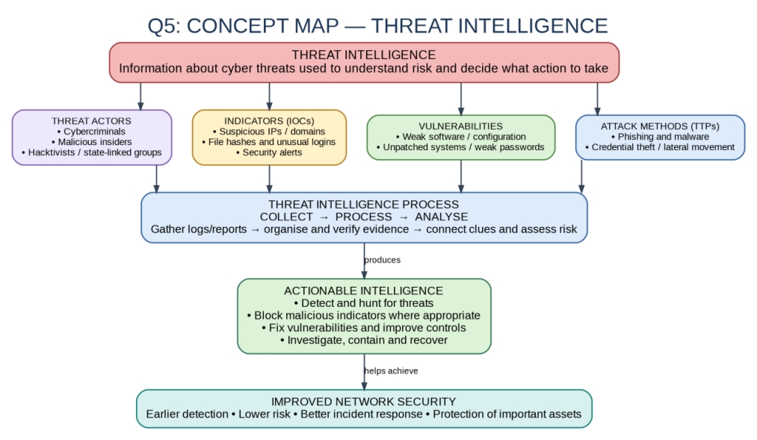
Explanation
Threat intelligence means collecting and analysing information about cyber threats so an organisation can understand risks and decide what to do.
Threat actors may use methods such as phishing or malware to exploit weaknesses. Indicators, including suspicious IP addresses, file hashes and unusual logins, provide clues that an attack may be happening.
Security teams collect information from logs, alerts and trusted reports. They organise and check the information, connect related clues and assess the risk. The result is actionable intelligence when it leads to a useful decision.
For example, if repeated login attempts come from an IP address linked to malicious activity, an analyst can check the logs, investigate possible account compromise and block the source when appropriate. This helps the organisation detect threats earlier and respond more effectively.

Q6. Concept Map — Types of Threat Intelligence
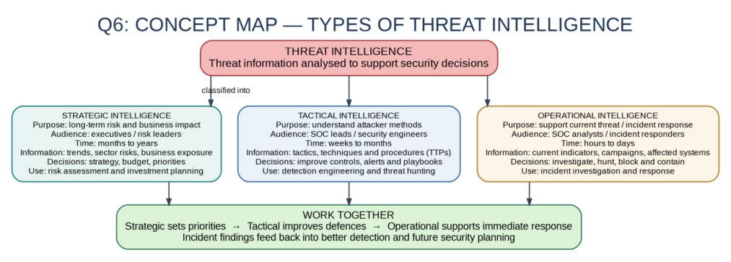
Explanation
Strategic intelligence gives management a broad view of cyber risks, business impact and long-term security priorities. It can help leaders decide where to invest time and budget.
Tactical intelligence explains how attackers operate, including their tactics, techniques and procedures (TTPs). Security teams use it to improve detection rules, controls and response playbooks.
Operational intelligence focuses on a specific threat or current incident. It can include current indicators, affected systems and campaign details, helping analysts investigate and respond.
The three types complement one another: strategic intelligence sets priorities, tactical intelligence improves defences, and operational intelligence supports immediate action. Findings from incidents can also improve future detection and planning.
Before submitting
Review the maps, make edits in your own words, and add an example from your class so the final work reflects your understanding.

